EXPT NO:6 | IMPLEMENTATION OF MULTIVARIATE DISPLAYS
DATE: 24.01.2026 | IMPLEMENTATION OF MULTIVARIATE DISPLAYS

PRE-LAB QUESTIONS

1. Why are multivariate displays important in AI analytics?
Multivariate displays allow visualization of multiple variables at the same time. They help identify patterns, relationships, and feature interactions in high-dimensional AI data, improving understanding and decision-making.

2. How do parallel coordinates differ from scatter plots?
Parallel coordinates can display many variables using parallel axes and polylines for each data point. Scatter plots show relationships between only two variables using points on X–Y axes.

3. What challenges exist in interpreting multivariate plots?
Multivariate plots can become cluttered and difficult to interpret with large datasets. Overlapping visuals and high cognitive load make pattern detection challenging without proper scaling and expertise.

4. Where are trellis displays commonly used?
Trellis displays are used in exploratory data analysis to compare patterns across categories. They are common in time-series analysis, subgroup comparisons, and model performance analysis.

5. How does multivariate visualization aid model evaluation?
It helps analyze feature impact, prediction errors, and bias across multiple variables. This improves model interpretability and helps detect overfitting or misclassification patterns.

OBJECTIVE : To implement advanced multivariate displays for complex data analysis.

SCENARIO A retail analytics firm studies sales, profit, customer segment, and region to optimize business strategy.

IN-LAB TASKS (Using R Language)
1• Create parallel coordinate plots

Code:
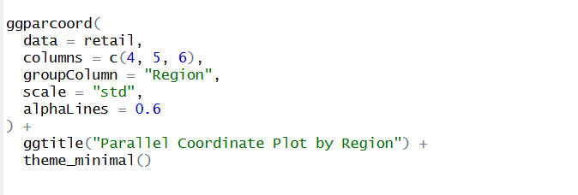

Output:
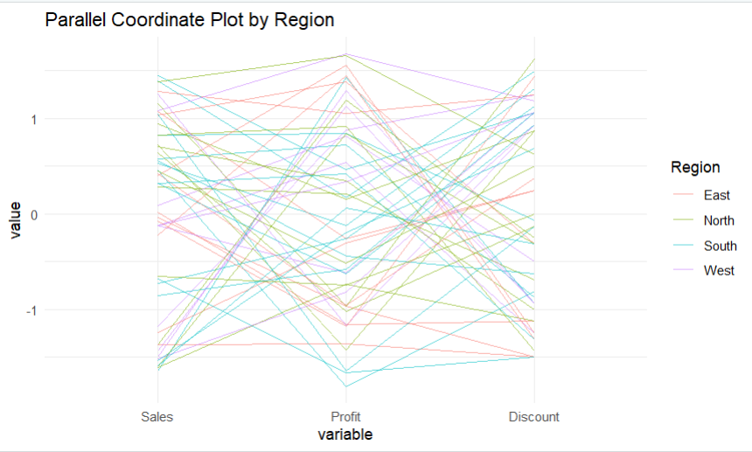
2• Generate bubble charts

Code:
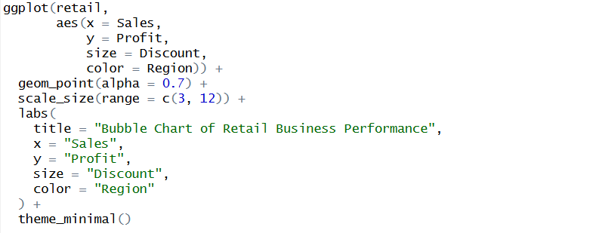

Output:
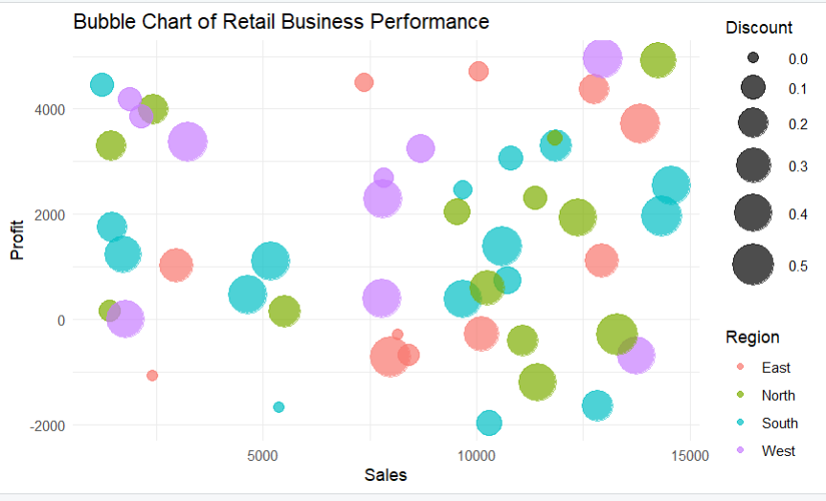

3• Implement trellis displays by region

Code:
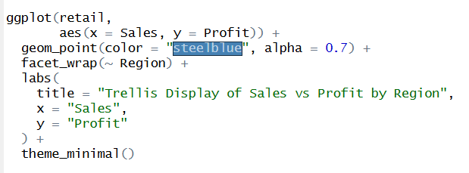

Output:
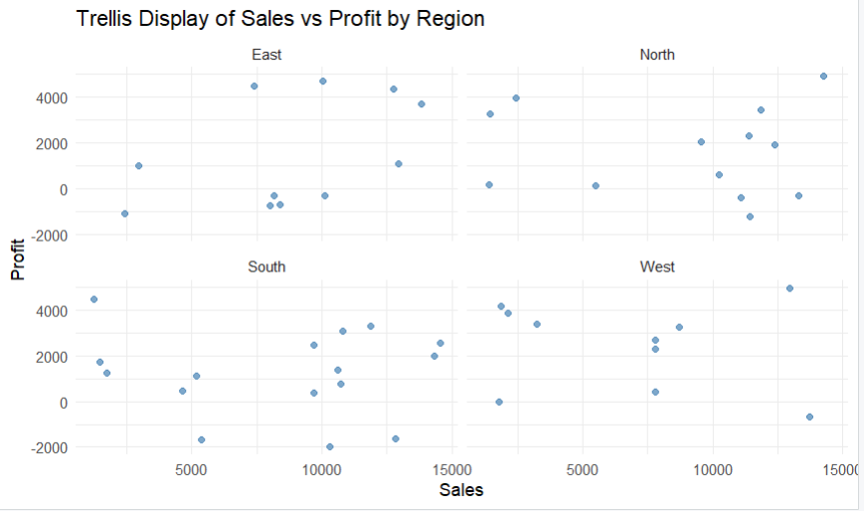

POST-LAB QUESTIONS

1. What insights are gained from parallel coordinates?
Parallel coordinates reveal relationships, patterns, and correlations among many variables at once. They help identify clusters, trends, and outliers in high-dimensional datasets.

2. How does faceting simplify complex data?
Faceting divides data into smaller, comparable subplots based on categories. This makes patterns easier to understand by reducing visual complexity.

3. What limitations exist in bubble charts?
Bubble charts can become cluttered when many data points overlap. Bubble size and area are also hard to interpret accurately, leading to misrepresentation.

4. How can these displays support AI-driven recommendations?
They help visualize user behavior, feature importance, and preference patterns. This improves understanding of relationships used by AI systems to generate recommendations.

5. Suggest improvements for large multivariate datasets.
Use dimensionality reduction, filtering, and interactive visualizations. Normalization and clustering also help reduce clutter and improve interpretability.

LEARNING OUTCOME: Students apply multivariate visualization for business intelligence.

ASSESSMENT
Description | Max Marks | Marks Awarded
Pre Lab Exercise | 5
In Lab Exercise | 10
Post Lab Exercise | 5
Viva | 10
Total | 30
Faculty Signature

